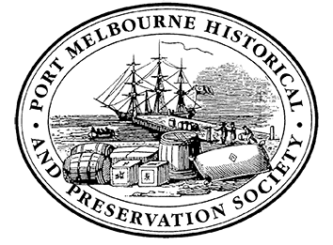
Agenda for General Meeting Port Melbourne Historical & Preservation Society
Tuesday 22nd November 2022
Port Melbourne Town Hall
Chair Person: Sue Leong

- Welcome Guests and Members :

- New Members: Barry Pemberton (no. 524)

- Apologies: David Thompson, Jack Bolt, Wyn May, Sheila Quairney, Brian Bethune, Alison Rowlands

- Vale Edward (Ted) Walter Raven

- Acceptance of Minutes 25th October 2022

- Matters arising from the minutes

- Reports
- Treasurer’s Report
- Correspondence (see below)

- Heritage Under Threat

- Other Business & Announcements
- Speakers program for 2023
- Excursion with Westgate Biodiversity Group on Sunday 20th November update
- Whittaker Commemoration Thursday 3rd November 12 Noon at Princes Pier update
- Remembrance Day Sunday 6th November summary
- Thursday 1st December “Port Characters – decade by decade” Janet Bolitho and Margaret Bride
- Christmas Artisan Market Saturday 3rd December 11am-4pm
- End of year picnic Sunday 11th December 12-3pm Edwards Park
- Recognition for Terry Keenan

Tonight: Trivia night with Mr. John May Esq.

Next Meeting: Tuesday 24th January 2023 – From the Archives

Correspondence
In: Invitation to 2022 Kenneth Myer Lecture Thursday 15th December
Out: Email to CoPP venues re chairs and tables

Note: When leaving tonight’s meeting, please exit via the door near the lift NOT the library entrance.

